GUIDELINES ON
RECOGNITION OF PRIOR LEARNING (RPL) OF CONSTRUCTION WORKERS’

Contents
Working Group Objectives and Process Followed 3
Background on skills in the construction sector 4
Construction sector overview 4
Current Skills Scenario 4
Current Initiatives 6
Recommendations of the Working Group 8
Recognition of Prior Learning Led Skill development Initiative for the construction sector 8
Assessment & Skill Development Framework 10
Assessment Process 11
Training Process 12
Training Impact (Tracer study) 13
Commercials and Payment terms 14
Annexure 1 – Criteria for partner selection 16
Assessment Partner Selection Criteria 16
Training Partner Selection Criteria 18
Annexure 2 – Enclosures 21

Working Group Objectives and Process Followed
Name: DGET Working Group on the Construction Sector
The Working Group was formed by the Director General of Employment and Training, Ministry of Labour, Government of India to evaluate the strategies for skill up-gradation of workers engaged in construction sector nationally in partnership with State Construction Welfare Boards (CWBs) considering the informal nature of the sector, large workforce and limited access to training and certification.
Members of the Group:
- DG, DGE&T, Chairman
- DG, NSDA or his representative, Member
- DG, CPWD or his representative, Member
- Chairman, National Institute of Open Schooling, Member
- DG, Construction Industry Development Council, Member
- CEO, Labournet, Member
- CEO, Pipal Tree Ventures Ltd, Member
- A representative of Larsen & Toubro, Member
- DDG (AT), Member
- DDG(E), Member
Mode of Working:
- Working Committee discussions
- Sub-working Group deliberations on implementation structure
- Interaction with the DGET, Ministry of Labour
- Preparation of draft recommendations and submission
Purpose:
The basic purpose of this sub-committee is to arrive at a skill development and certification initiative for the purpose of skills up-gradation in the construction sector based on the concept of Recognition of Prior Learning. As an outcome of this exercise, the proposed Recognition of Prior Learning (RPL) led skill development initiative for the Construction sector will be proposed for implementation in partnership with the various State Construction Welfare Boards (CWBs) and DGET, Ministry of Labour.

Background on skills in the construction sector

Construction sector overview
Construction activity creates physical assets in a number of sectors of the economy. Construction Sector has two key segments : (i) Buildings, falling into one of the following categories : residential commercial institutional and industrial; and (ii) Infrastructure such as road, rail, dams, canals, airports, power systems, telecommunication systems, urban infrastructure including water supply sewerage and drainage and rural infrastructure. Assets once created also need to be maintained. Many upstream economic activities depend upon the construction sector.
By 2050, half of the Indian population will be living in urban areas, so there is an urgent need for urban redevelopment and improved public transportation. The Indian government proposes to build 100 smart and safe cities and has identified this as the top most priority of the Government. The Government plans to lower urban density by building satellite towns and cities that are attractive. This will give huge fillip to construction activities in all its sphere and associated activities.
Although construction does not strictly fall under the service sector, it is considered as a potential sector for employment generation and similar in the nature of activities and labour with many service sub-sectors. The growth in construction sector in GDP has primarily been on account of increased spending on physical infrastructure in the last few years through programmes such as National Highway Development (NHDP) and PMGSY/BharatNirman, etc.
In 2010-11, this labour intensive sub-sector has contributed around 8.1 per cent (revised estimate) to GDP. Accordingly to the NSS 66th round data (2009-10) construction sector generated 44.69 million employment and recorded CAGR of 11.69 per cent during 2004-05 to 2009-10, highest in the economy. With an estimated 23 USD $ 1 trillion planned investment, the construction sub sector holds immense potential for employment generation ((Economic Survey 2010 – 11).

Current Skills Scenario
The construction sector is a large employer with 42.3 million construction workers in the age-group of 15-59 yrs. The sector is predominantly comprised of male workers (85%) & 76.4 % belong to rural areas. There is a national footprint of distribution of construction workers - UP, Rajasthan, TN, MP and AP account for about 50% of total construction workers. Although it offers easy entry to the unemployed, particularly migrant workers poor working conditions, low wages, and inadequate provision for social security are issues of concern. The sub-sector also engages a high share of female workers, poor working conditions, low wages, and inadequate provision for social security are issues of concern. The sub-sector also engages a high share of female workers in the unskilled category, with significant wage differentials and almost no prospect of vertical mobility. Productivity remains low as the majority of construction activities are carried out in the unorganized segment.
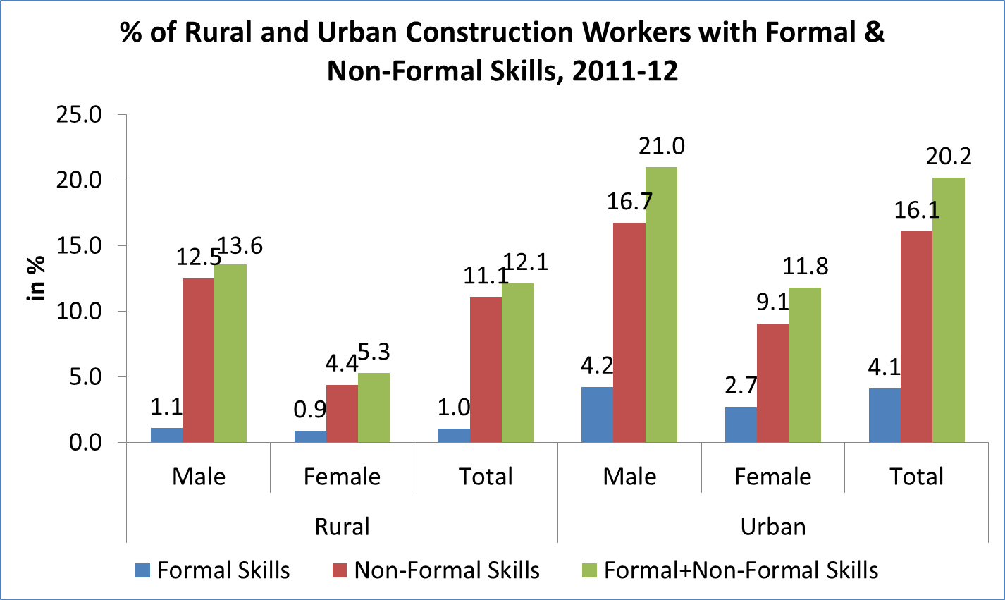
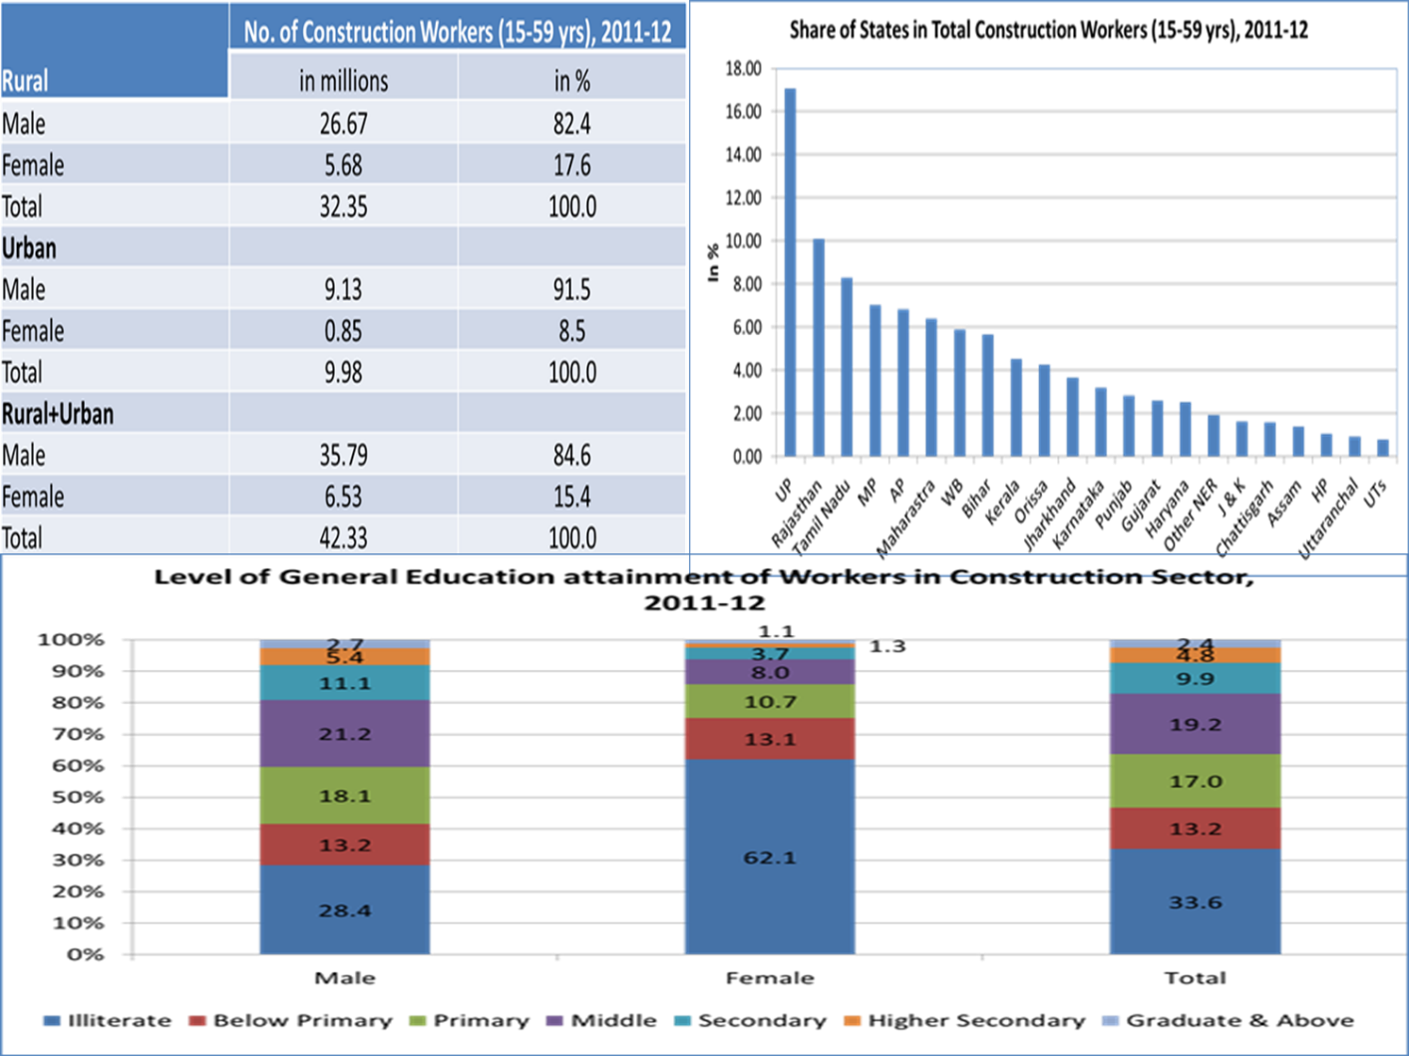

Current Initiatives
The last few years have witnessed several initiatives to improve the condition of workers in the sub-sector. The most notable intervention is the enactment of the Building and Other Construction Workers (Regulation of employment and Conditions of Services) Act, 1996 that seeks to provide for regulation of employment and conditions of service of the building and other construction workers as also for their safety, health and welfare measures and other matters connected therewith or incidental thereto.
One of the most important features of the Act is the constitution of the welfare fund. The fund is to be utilized for welfare measures like immediate assistance in case of accidents; pensions to those who have completed sixty years; sanction of loans for the purpose of construction of the house; premium for group Insurance scheme; financial assistance for the education of the children of the beneficiaries; medical expenses for the treatment of the major ailments of the beneficiaries; maternity benefits for the female beneficiaries; grant loan or subsidy to a local authority or an employer in aid of any scheme; and pay annually grant-in-aid to a local or an employer who provides welfare measures. The fund is to be managed and operated by Welfare Boards to be constituted by the States. The major source of the funds of the Boards shall be, collection of cess at the rate not exceeding 2 per cent of the cost of construction incurred by an employer under the Building and Other Construction Workers Welfare Cess Act. Although some State governments have framed rules and operationalized the welfare funds, several states are yet to conceive welfare schemes and implement the same.
Yet another positive development is series of programmes initiated to improve the skill base of those involved in the sub-sector. This gains importance considering the fact that a study by Confederation of Indian Industry (CII) has project the demand for skilled workers in the construction sub-sector to be 15 million by 2015, while the present training capacity within the sub-sector is merely 4.4 lakh per annum.
One such approach to upgrade the skills of workforce in construction sector is recognition of prior learning (RPL). Recognition of Prior Learning (RPL) – whereby skills and knowledge gained by individuals outside formal learning processed are assessed and granted formal recognition – has become an increasingly important topic within skills policy in recent years. It is seen as a tool for delivering a fairer, more efficient, more flexible and more inclusive skills system, and it is of increasing interest to developing countries wishing to make better use of their existing human resources.
Ministry of Labour & Employment launched SDIS to provide vocational training to people to improve their employability. The scheme has been operationalized since May 2007. During XI plan period (2007-12), against an approved outlay of Rs.550 crore, an amount of Rs.407 crore was spent and 13.67 lakh persons were trained or directly tested under the scheme. Cabinet Committee on Skill Development has approved the continuation of Skill Development Initiative Scheme for XII Plan period with certain changes on 13-08-2013.
An outlay of Rs.1200 crore has been kept for the scheme for 12th plan period. Total, 25 lakh people would be skilled & certified during 12th Plan period. This would improve their employability & help industries get skilled workforce.

Recommendations of the Working Group
Based on the extensive discussions held by the Working Group, the recommended model for the skills up-gradation for the workers in the construction sector is based on a competency led Recognition of Prior Skills (RPL) certification framework.
The initiative envisages an assessment led measurement and certification process for validating current skills and gap training (in trade and supporting competencies) for fulfilling needs. This training will be aligned to the National Skills Qualification Framework (NSQF) and incorporates the trade-wise competencies designed in the National Occupational Standards (NOS).

Recognition of Prior Learning Led Skill development Initiative for the construction sector
The skill development initiative design will have participation from Training and Assessment Partners along with industry partners – the programme will be anchored by DGET and the State Construction Welfare Boards.

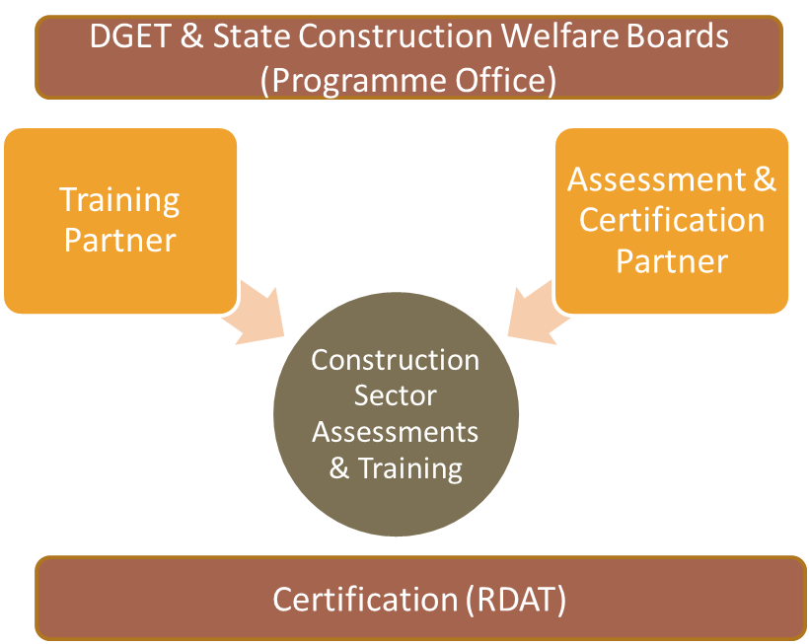

- Training Partner and independent Assessment Partner to be empanelled for the skills initiative – there will be an independent assessment of learner skills
- Partner evaluation framework – Based on their technical/industry expertise and execution skills
- Bench of Assessment Partners (AP) & Training Partners (TP) to be selected centrally by DGET; states to have flexibility in nomination of partners from this bench for the rollout of the scheme
- Partner review jointly by Centre & State representatives after each year (addition of new partners, dropping of current partners) based on performance/ eligibility norms

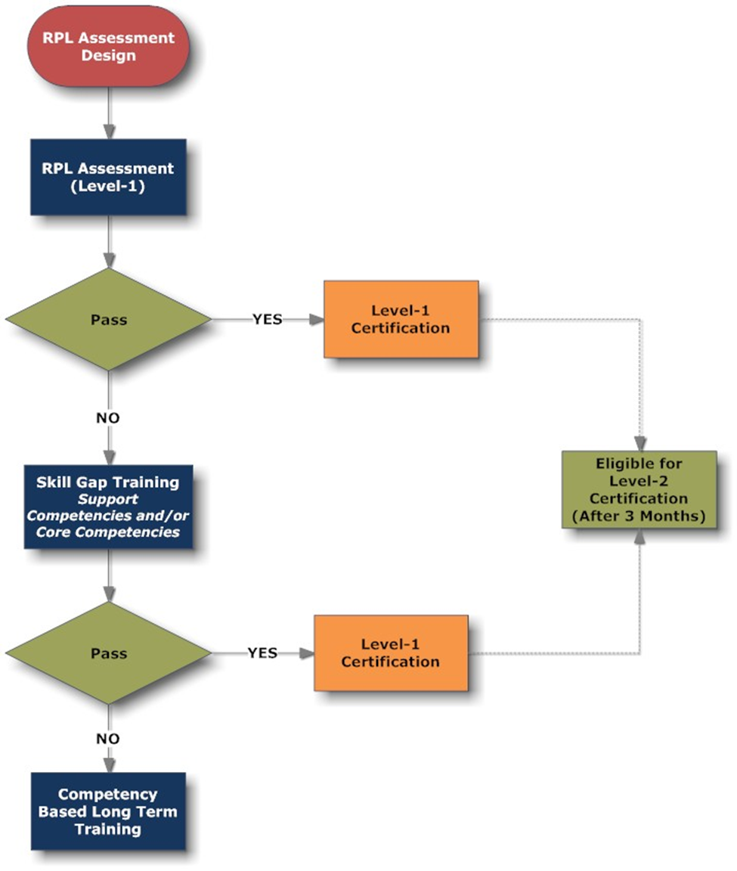
Competency Based Assessment & Training

- NSQF Level 1: Helper (‘Unskilled’ in industry parlance)
- NSQF Level 2: Assistant Tradesman (‘Semi-Skilled’ in industry parlance)

Skill Gap Training (Based on hours required)
- Support Competencies Training: Approx 40 hours
- Core Competencies Training: Approx 80 hours

- Certification linked to clearing of all National Occupational Standards (NOS) within the Qualification Pack (trade-wise)
- Training & Assessment centre can be at a worksite/ standalone centre – needs to be have classroom & training yard and has to be approved by competent authority
- Certified learner (more than 75% in both sections) to be eligible for next higher level certification post 3 months of certification date.
- The recommended grading is as below:
Grade | Interpretation | Result
A | >75% in both core (technical) & supporting competencies section | Certification
B | >75% in core (technical) NOS, <75% in supporting competencies | Partial skills recognition  Skill Gap training in Supporting competencies + Final assessment + Certification
C | <75% in both core (technical) & supporting competencies section | Partial skills recognition  Skill Gap training in Core (technical) and Supporting competencies+ Final assessment + Certification
D | <30% in both core (technical) & supporting competencies section | Fail  To undergo complete course training (competency based)

Assessment & Skill Development Framework

The skill up-gradation initiative is envisaged primarily as a worksite led training intervention considering the accessibility element considered vital to the construction sector (important for participation of workers) and also the relevance in providing best-in-class industry endorsed training. The Training Partner will anchor tie-ups with various industry partners (real estate companies, infrastructure companies etc.) and establish Training Centers at their work-sites to facilitate assessments and training of the current workforce.

The number of unskilled and semi-skilled learners (workers) should be > 200 across the 6 trades in a typical work-site. There is a cluster of such sites envisaged in each city/ region that will be supported by a project management team from the Training Provider.

The skills up-gradation will span the 2 entry level roles in the following trades - these trades account for the maximum strength of workers across any construction site:
- Bar Bending
- Masonry
- Shuttering Carpentry
- Plumbing
- Painting
- Scaffolding

Assessment Process

- Assessment Design
  - Map the job role requirement and competency design required for assessments
  - Structure the assessments to capture the level of both theoretical and practical knowledge of the individual
  - Staffing: 1 assessor for 20 - 25 learners across trades(per day); trade based certification for the assessor
- Learner Briefing
  - Mobilization and categorization of learners (trade-wise)
  - Batch-making and completion of enrolment forms
  - Briefing on assessment initiative (process, scoring criteria, training indicated) and other requirements
- Assessment
  - Ensure all the requirements (Rooms, Stationery, ‘Show & Tell’ section etc) for the assessments are met as per the process mandate
  - Conduct the assessments as per the guidelines mandated as per process guidelines
  - Ensure all the requirements (Assessment area in Training Yard, Tools & Equipment) for assessments are met as per the process mandate
  - Certification
  - Certify the candidates based on assessment scores (detailing shared in ‘Masonry Evaluation’ format attached)
  - Forward the list of passed candidates for certification processing
  - Award the learner with the hard copy of DGET approved competency based certificate
  - Storage & Database
  - Deploy IT Capabilities to store certification data and make them easily retrievable across sites for review by multiple stakeholders

Training Process

- Course & Content Design
  - Design the content based on the job role requirement
  - Structure the training course as per the approved pedagogy methods which will be a healthy mix of theory and practice
  - Staffing: 1 Trainer for every 25 – 30 learners
- Client Interaction
  - Anchor the industry partner tie-ups and ensure Training programme initiation at work-sites (training yard and infra set-up, materials)
  - Discuss the relevance and significance of the training program to site-managers & sub-contractors
  - Ensuring the attendance of the learners
- Registration
  - Registration process to be completed for each and every individual attending the program
  - To follow the registration process as mandated as per process guidelines
- Training
  - Deliver the training as per the requirement based on competency based outcomes
  - Training conducted following all the mandates provided as per process guidelines
  - Attendance reports to be shared for payments
- Final Assessment
  - Final assessment (Practical & Theory) to be carried out for checking the training efficacy
  - Results will be made accessible to all key stakeholders
  - Assessment to be carried out as mandated as per process guidelines
- Storage & Database
  - Deploy IT Capabilities to store certification data and make them easily retrievable across sites for review by multiple stakeholders

Training Impact (Tracer study)
The skills up-gradation initiative will incorporate a robust impact evaluation mechanism that will assess training effectiveness, placement/ work enablement due to increase in skills and the subsequent income increase. The main points of the initiative are shared as below:
- Tracer study based on the National Skills Development Agency (NSDA) framework designed with the support of International Labour Organization (ILO)
- Measurements at 5 weeks, 25 weeks and 50 weeks post certification
- Tracking of two parameters – skills increase due to training and rise in income levels
- Tracer study to be de-linked from training and certification partners – to be anchored by an independent anchor
- Assessments to be conducted for a sample base of the selected learners (discrete sampling method – 10% of learners)
- Report format for the initiative to be shared with the DGET, State CWBs and other relevant stakeholders

Commercials and Payment terms
Item | Cost Per Learner (INR)
RPL/ Final Assessment Assessment (each) | 1000
15 Days Training (8 hours each = 120 hours) | 3500
7 Days Training (8 hours each = 56 hours ) | 1750
Certification | 500
Impact (Tracer Study) | 500
Wage allowance to learner (to offset income loss during training) | INR 35 per hour

Note:
- RPL & Final Assessment, Training, Certification & Impact components to be provided under SDIS budget - Fortnightly clearance based on certification data
- Wage allowance to be provided under BOCW centrally – initiative level arrangement (disbursal through DGET) to be finalized
- Certification & Tracer study – to be anchored by separate entities

Component | Details
Assessment (RPL & Final Assessment) | Source of funding - can be funded through SDIS  Payment milestones  - 100% payment within one month of assessment results upload
Training | Source of funding - can be funded through SDIS  Payment milestones  - 50% advance on training batch enrolment in the online system (against performance guarantee provision to be enabled by each Training Provider)  - Remaining 40% payment within 1 month of final assessment based on attendance reports  - Final 10% to be paid based on successful certification  >60% candidates certified – 10% payment  < 60% certified - 0% payment
Certification | Source of funding - can be funded through SDIS  Payment milestones  - 100% payment on submission of details to the database and generation of certificate
Wages (wage loss off-set to learners) | Source of funding - can be funded through BOCW centrally  Payment milestones  - 100% payment on submission of skill training attendance details to the database
Impact evaluation (Tracer study) | Source of funding - can be funded through SDIS  Payment milestones  - 50% payment post submission of the learner details (impact calls/ visits)  - Remaining 50% payment based on submission of reports for 10% sample size

Annexure 1 – Criteria for partner selection

Assessment Partner Selection Criteria
Criteria | Score Weightage
Organization Profile
Experience | 20
Financial Turn Over | 20
RPL Assessed Candidates | 10
Candidates Certified | 10
Technical Capability
RPL Methodology | 10
RPL Assessment Design | 10
Faculty and Assessors | 25
Database & Storage | 20
Certification Methodology | 10
Certificated Faculty | 25
Infrastructural Capability
Reach of the Organization | 20
Capacity to Provide Assessment Services | 10
Capability to Provide Certification | 10

Assessment Partner – Organization Profile
Experience
- A company/partnership/society/trust operating engaged in preferably assessments, certifications or Training as its main activity for the last two years
- Preference for organizations that are promoting training and certification for workers in the construction industry.
- Details of the construction sector based clientele

Financial Turnover
- Should have average annual turnover/receipts of INR 1 crore from conducting assessments and/or training programs during the last two years.
- Should have a positive net worth as on application date.

Assessed Candidates
- Should have conducted assessment for 5,000 candidates on a consolidated basis during the last two years.
- Preference for organizations that have completed over 1000 assessments in the construction sector during the last two years.
- Assessment Criteria (vocational skill oriented assessments pertaining to any of the following):
  - Assessment for the courses or modules or job roles notified by NCVT/SCVT/Sector Skills Council
  - Assessment for the training Programmes sponsored/ recognized by any state or central government department/ministry.
  - Assessment for training Programmes being conducted under NVEQF

Assessment Partner – Technical Capability
Methodology (as a parameter for selection)
- Methodology employed to train the assessor (Theory & Practical)
- Assessment methodology used to certify the trainers

Assessment Design Experience
- Government bodies or industry bodies approved assessment design by the organization (Preferably in construction sector)

Faculty & Assessors
- One Master Trainer / Assessor with relevant qualification and at least 10 years of industry experience and 2-3 years of experience in deploying assessment
- Ten trainers / Assessor with relevant qualification and at least 5 years of industry experience and 2-3 years of training experience in deploying assessment (3 years of overall experience in case Std X pass)
- Detailed CV’s of the Master Trainer & Assessor/ Trainers

Storage & Database
- Database management design and system employed

Methodology
- Methodology employed to train the assessor/certifier
- Assessment & certification methodology employed to certify the candidates (Theory & Practical)
- Assessment / certification methodology used to certify the trainers & candidates

Assessment Partner – Infrastructure
Reach of the Organization
- Should have operations in at least two states and five districts with a track record of operating a minimum of twelve centers of assessments or training in construction sector

Capacity to Provide Assessment
- Details of the infrastructural facilities to conduct assessment & certification
- Understanding of the machineries and equipment to conduct the assessment & certification

Training Partner Selection Criteria
Criteria | Score
Organization Profile (Annexure 2.4)
Experience | 10
Financial Turn Over | 10
Candidates Trained | 05
Placement | 05
Technical Capability (Annexure 2.5)
Methodology | 10
Content Design Experience | 10
Certified Faculty and trainers | 30
Infrastructural Capability (Annexure 2.6)
Reach of the Organization | 10
Capability to Provide Training | 10

Training Partner – Organization Profile
Experience
- A company/partnership/society/trust operating engaged in preferably assessments, certifications or Training as its main activity for the last two years
- Preference for organizations that are promoting training and certification for workers in the construction industry.
- Details of the construction sector based clientele

Financial Turnover
- Should have average annual turnover/receipts of INR 1 crore from conducting training programs during the last two years.
- Should have a positive net worth as on application date.

Candidates Trained
- Should have conducted training for 5,000 learners on a consolidated basis during the last two years.
- Preference for organizations that have trained over 1,000 learners in the construction sector during the last two years.
- Training Criteria (vocational training of a minimum duration of 50 hours in the sectors or modules pertaining to any of the following):
  - Courses or modules or job roles notified by NCVT/SCVT/Sector Skills Council
  - Training Programmes sponsored/ recognized by any state or central government department/ministry.
  - Training Programmes being conducted under NVEQF

Training Partner – Technical Capability
Methodology
- Methodology employed to train the trainer (Theory & Practical)
- Training methodology employed to train the candidates (Theory & Practical)
- Assessment methodology used to certify the trainers & Candidates

Content Design Experience
- Government bodies or industry bodies approved vocational skill training content’s developed by the organization (Preferably in construction sector)

Faculty & Trainers
- Two Master Trainers with relevant qualification nd at least 10 years of industry experience and 2-3 years of training experience
- Ten Trainers with relevant qualification and at least 5 years of industry experience and 2-3 years of training experience (3 years of experience in case Std X Pass)
- Every site should have a ITI trained Faculty member with 3 years of construction sector experience as a ‘Senior Trainer’
- Detailed CV’s of the Master Trainers & Trainers

Training Partner – Infrastructure
Reach of the Organization
- Should have operations in at least two states and five districts with a track record of operating a minimum of twelve centers in construction sector.

Infrastructural Capacity to Provide Training
- Details of the infrastructural facilities to conduct training; this has be arranged in association with industry partners also (no compulsory own infrastructure requirement)
- Details of the machinery and equipment to conduct the training
- Able to have tie-ups with Corporates to utilize work-site for training (details to be shared)

Annexure 2 – Enclosures
Assessment Checklist Format
Curriculum for the trades
Certification template

